Report #3  
 validate the script about the surface reaction mechanism over Nickel catalyst

# *.cti input file

From the data about the surface reaction mechanism and the thermodynamic of species adsorbed over catalyst were gotten from website detchem.com, which be in <<*.txt>> format. I tried to convert by script <<ck2cti.py>> but it doesn’t work because of the format errors or the syntax (I think so). Although, I searched these errors on Internet and on the Cantera Group, it still be not resolved. So, I decided create by hand (copy and past), fortunately, the number of reaction and number of species are small enough to do it well (52 reactions with 6 gas-phase species and 14 surface species). I also review this cti file many time to make sure everything is right !

*Result: We have a mechanism file <<Ni_surf_mech.cti>>

# Experimental parameters

Karla Herrera Delgado *et al.* [1] (the reference [7] in previous report #2) set up the experiment about dry reforming of methane in a fixed-bed reactor as depicted in Fig.1 [1]

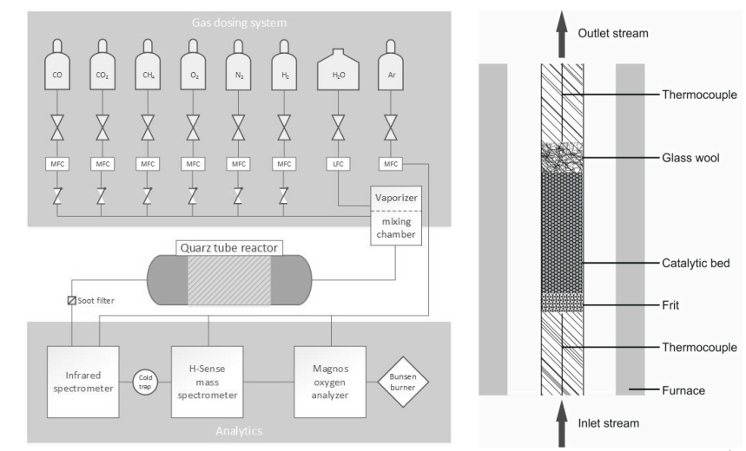

Figure Schematic diagram of the experimental setup used for catalytic reforming experiments over a nickel bed catalyst [1]

The reactor is a quartz tube with inner diameter of 100 mm filled with 20mg of nickel-based catalyst with a reaction zone of 27 mm length. The reactor will be conducted at isothermal condition. The Nickel catalyst bed has porosity and Active catalytic area to volume ratio (Table 1).

|  |  |
| --- | --- |
| Inner diameter of reactor |  |
| Length of reaction zone |  |
| Porosity |  |
| Active catalytic area to volume ratio |  |

Table Summary the parameter of experiment

They investigated three case: Methane Dry Reforming, Methane Stream Reforming and Methane Catalytic Partial Oxidation.

## 2.1. Dry Reforming of Methane (DRM)

The total volume flow rate of gas mixture is at , the mole fraction of each inlet species is in table 2

|  |  |
| --- | --- |
| Species | Volume percent (%) |
| N2 | 96 % |
| CH4 | 2 % |
| CO2 | 2 % |

Table Gas mixture

They investigated the concentration (%) of reactants and products as a function of temperature. From their result (Fig.10 of reference) and our script, we have the comparisons.

*Caption about result of reference: *experimentally determined (symbols); numerically predicted (lines); dashed lines = equilibrium composition at given temperature*

*Our script has the same result of numerical predict of reference about the Dry Reforming of Methane

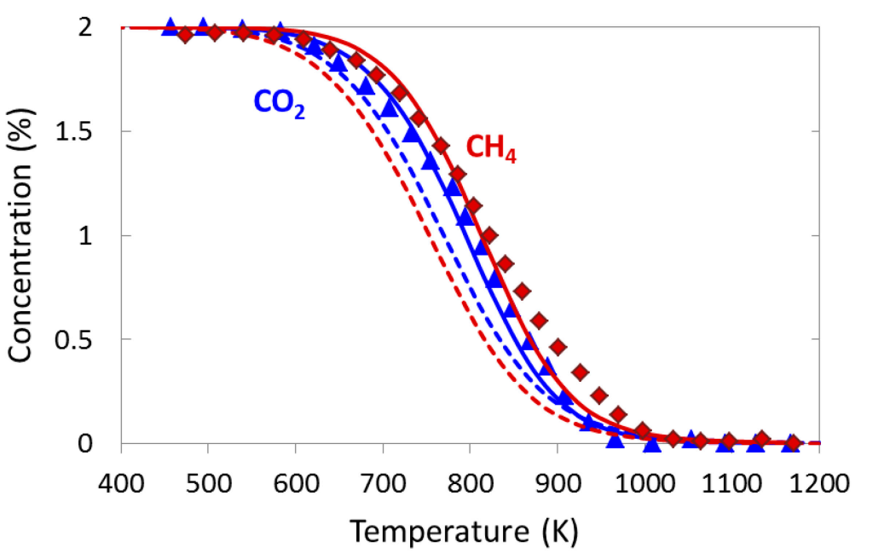

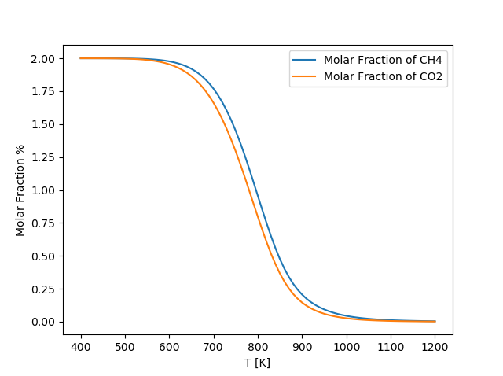

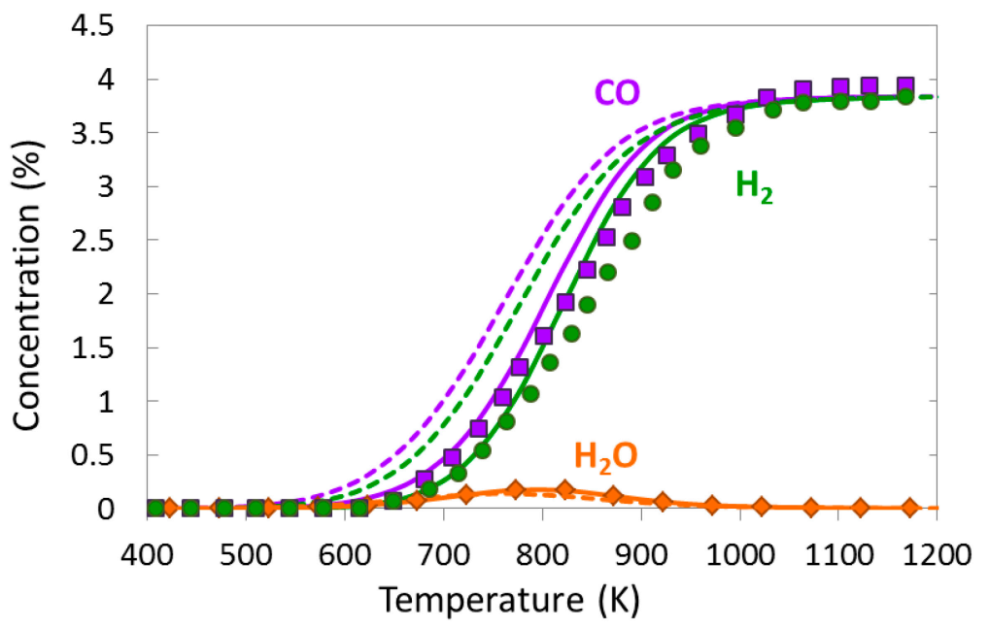

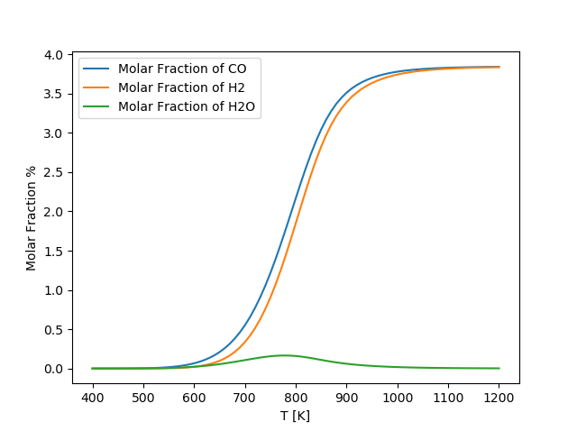

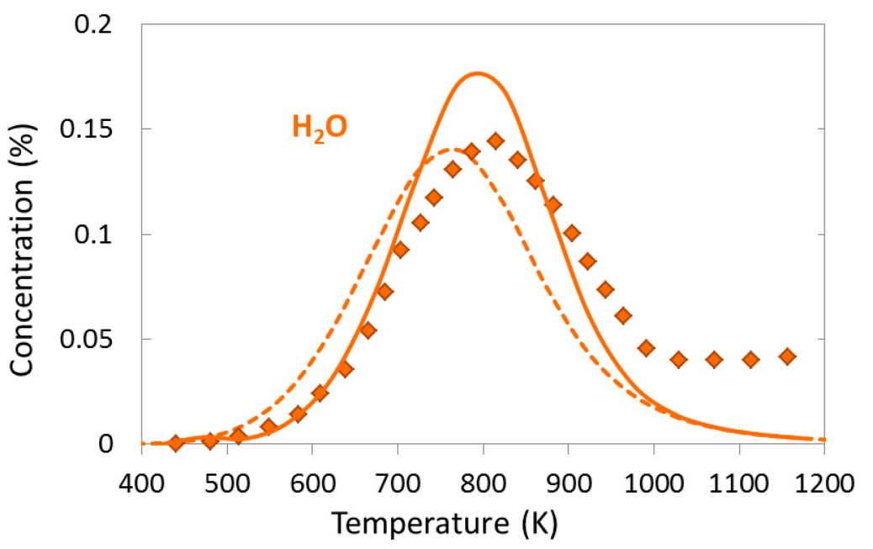

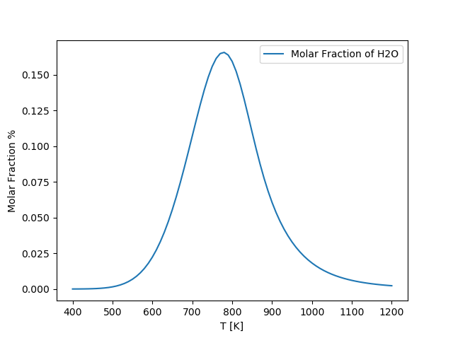

## 2.2. Stream Reforming of Methane (SR)

The total volume flow rate of gas mixture is at , the mole fraction of each inlet species is in table 3

|  |  |
| --- | --- |
| Species | Volume percent (%) |
| N2 | 96,4 % |
| CH4 | 1,6 % |
| H2O | 2 % |

Table Gas mixture

They investigated the concentration (%) of reactants and products as a function of temperature. From their result (Fig.7 of reference) and our script, we have the comparisons.

*Caption about result of reference: *experimentally determined (symbols); numerically predicted (lines); dashed lines = equilibrium composition at given temperature*

*Our script also has the same numerical results of reference !

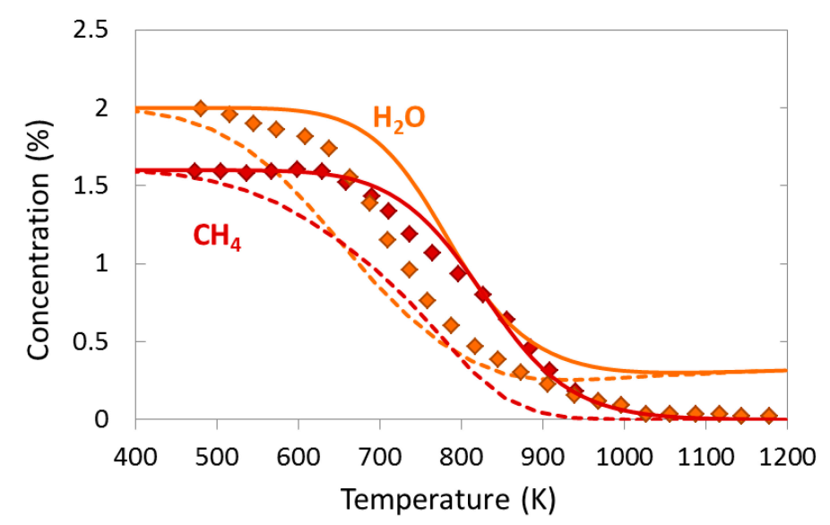

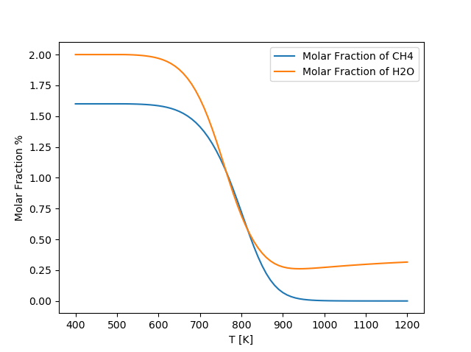

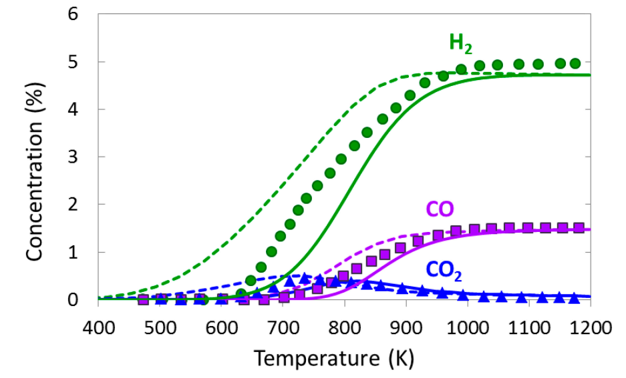

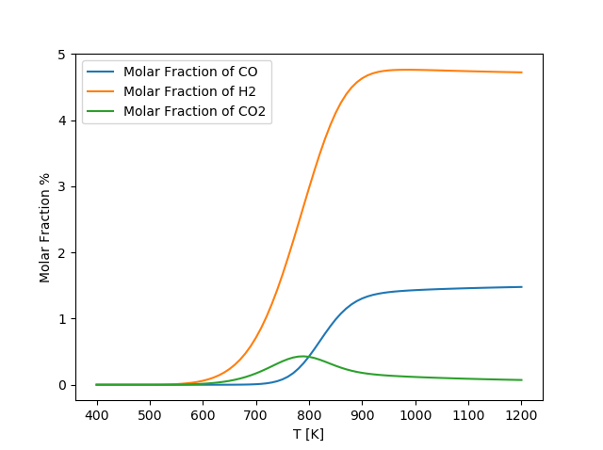

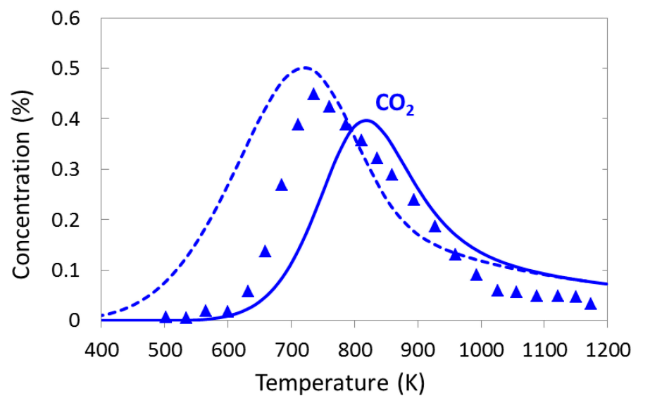

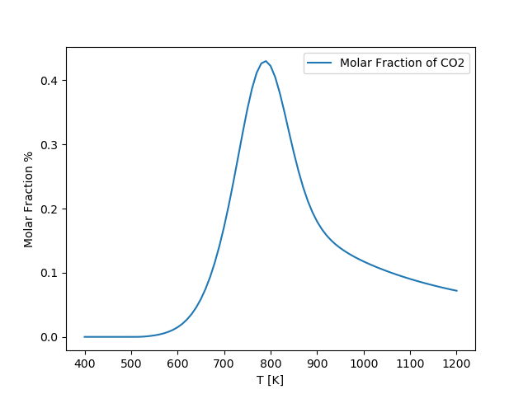

Figure Comparison our script with the numerical results of reference

## 2.3. Methane Catalytic Partial Oxidation (CPOX)

There are two mechanisms to explain this case. Firstly, The direct oxidation mechanism where H2 is directly originated from methane decomposition. Secondly, The indirect route where methane is totally oxidized to CO2 and H2O, as long as oxygen is present close to catalyst surface, and then the remaining CH4 is reformed with stream or CO2 to H2 and CO [1].

The total volume flow rate of gas mixture is at , the mole fraction of each inlet species is in table 4

|  |  |
| --- | --- |
| Species | Volume percent (%) |
| N2 | 96,4 % |
| CH4 | 1,6 % |
| H2O | 2 % |

Table Gas mixture

They investigated the concentration (%) of reactants and products as a function of temperature. From their result (Fig. 3 and Fig. 4 of reference) and our script, we have the comparisons.

*Caption about result of reference: *experimentally determined (symbols); numerically predicted (lines); dashed lines = equilibrium composition at given temperature*

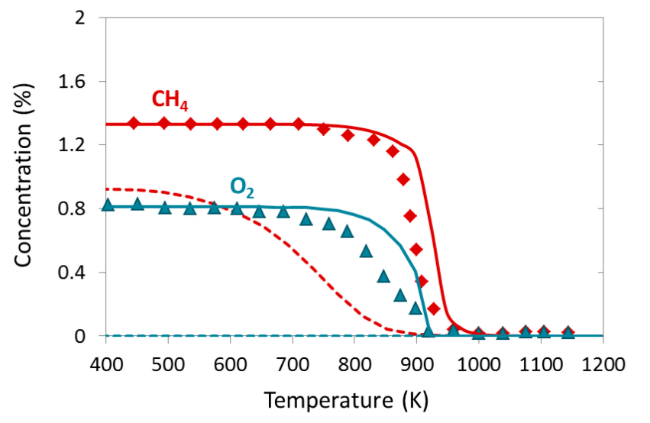

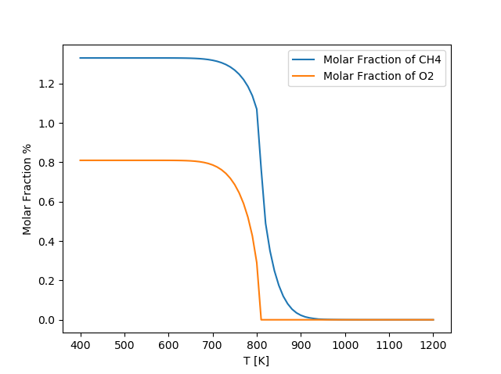

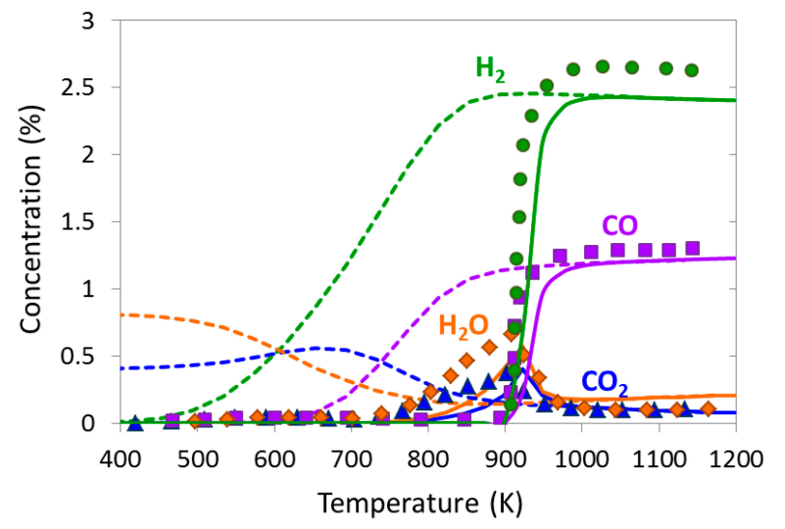

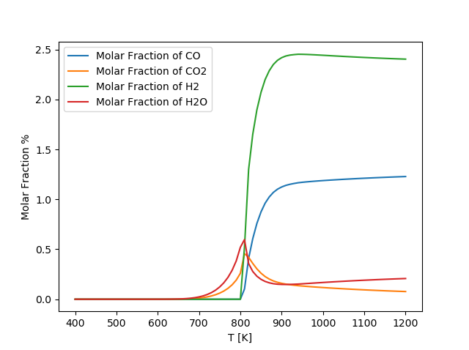

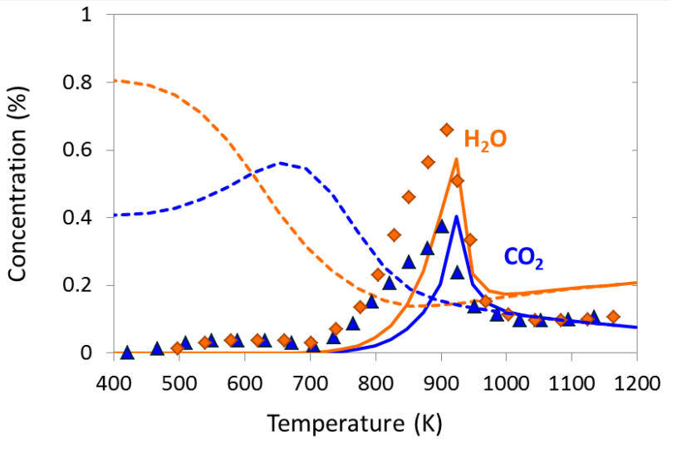

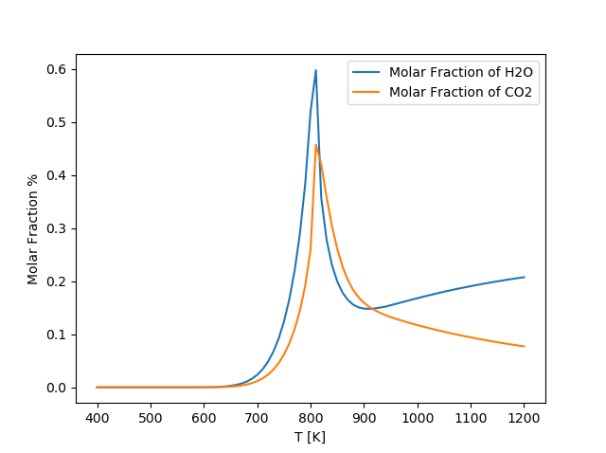

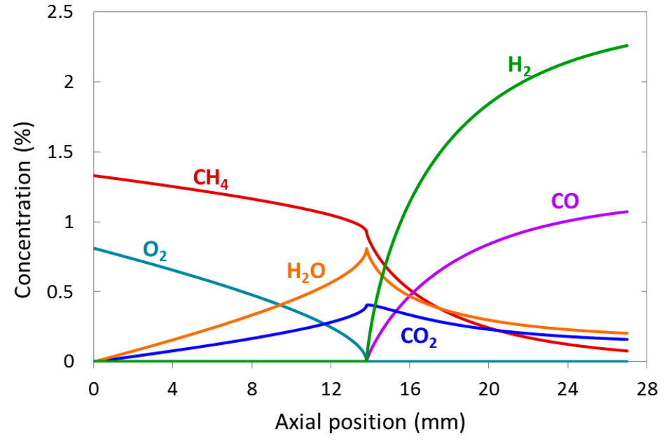

Total Oxidation of Methane

Stream and Dry reforming of Methane

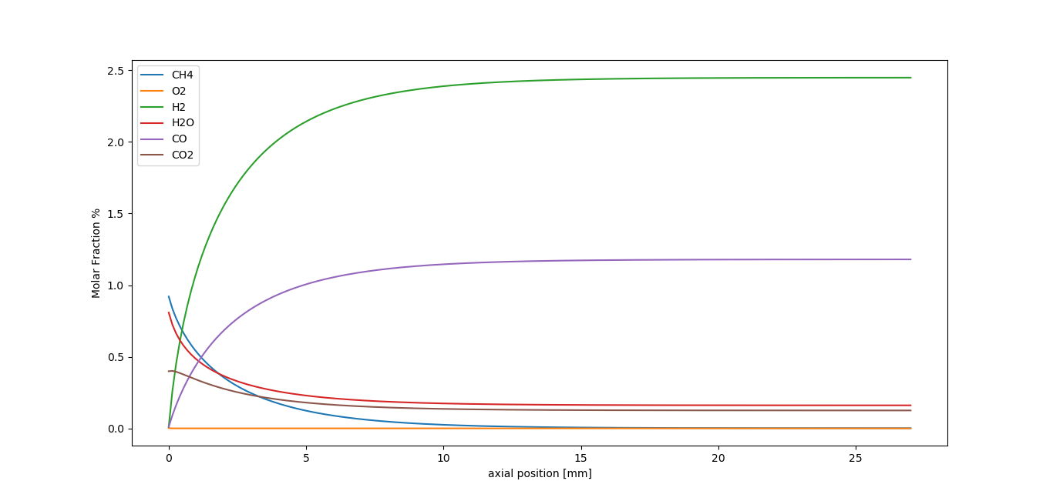

The plot about the concentration as a function temperature of our script is shifted to left approximately in comparison with the reference. The result about ***molar fraction vs axial position*** is also different from the reference. we can see that the molar fraction of all species at the beginning of reactor of our script equal the molar fraction of all species at the position 14mm of reactor of reference.

The reason why is the mechanism for this case that could be divided by two steps. At the beginning of the catalytic bed **CO2 and H2O are first formed by total oxidation of methane** [1] (this part of mechanism is not included in the reference), whereas **H2 and CO are produced through steam and some dry reforming of methane** further downstream when oxygen is completely consumed [1]. It means at the position 14mm, it will start occurring the steam and some dry reforming of methane reaction.

*Note: To use script for this case, we have to add the *Methane Total Oxidation mechanism* into the cti file.

# Conclusion

Our script is suitable for two case ***Stream*** and ***Dry Reforming of Methane*** (SR & DRM), but not for ***Methane Catalytic Partial Oxidation*** (CPOX). Because our objective is to simulate the dry reforming of methane coupling the plasma and the catalyst, so we could neglect the ***Methane Catalytic Partial Oxidation Mechanism*** (CPOX), and could use this script for next steps.

In the case, we would use the ***Methane Catalytic Partial Oxidation Mechanism***, I will find out more information about it.

Furthermore, This surface reaction mechanism only concern about the Nickel catalyst, it doesn’t state about the influence of support metal (for example AL2O3 in the Ni/AL2O3 catalyst) and the influence of Nickel fraction in a supported catalyst. But I think these influences are directly related to two parameters of catalyst bed: **the porosity** and **the active catalytic area to volume ratio**.

# References

|  |  |
| --- | --- |
| [1] | L. M. S. T. l. Z. H. S. O. D. Karla Herrera Delgado, "Surface Reaction Kinetics of Steam and CO2 - Reforming as well as Oxidation of Metane over Nickel-Based Catalysts.," *Catalyst,* no. 5, pp. 871-904, 2015. |

Link:

Gantt chart: <https://docs.google.com/spreadsheets/d/1pgTm9QTVgA2n_2NetLwpwnbW8kADJNP6VqgRpcv_keI/edit?usp=sharing>